Online Consent Management & Monitoring System

User Manual for Industries

**GUIDELINES FOR INDUSTRIES TO FILE APPLICATION ONLINE FOR CONSENT OF THE BOARD**

**Puducherry Pollution Control Committee**

**Revision Sheet**

|  |  |  |
| --- | --- | --- |
| **Release No.** | **Date** | **Revision Description** |
| Rev. 0 | 17/10/2016 | User’s Manual Template and Checklist |
|  |  |  |
|  |  |  |
|  |  |  |
|  |  |  |

# INTRODUCTION

Online Consent Management & Monitoring System is a web based application for Consent Management developed for the PPCC (Puducherry Pollution Control Committee), by NIC, Cell, and Ministry of Environment & Forest. The details of **Industry User** as given below.

## Features of OCMMS

* Unified Global online application/ portal
* Role based application access
* Multi level Security Enabled System
* Online Industry Registration
* Online Submission of Application, Approval, Clarification and other activities for CTE, CTO for all category of Industries / Institutions

1. **ONLINE INDUSTRY REGISTRATION**

Industry registration is an online feature; which will enable Industry applicant to register himself online to use the application for applying for Consents (CTE/CTO), Authorization and other features. Using this Industry will be able to generate the user temporary name and password, which he needs to use within the stipulated time. Once Industry uses the temporary user name and password for Consent Application; documents/details provided with this will be validated and user name will be confirmed and made available to him for future use. If Industry fails to use the temporary user name within the given time frame, then this user name will be deleted from the database and applicant will have to re-register himself to use the online application.

**For New Industry Registration Click on “New Industry Registration” Link at Home Page.**

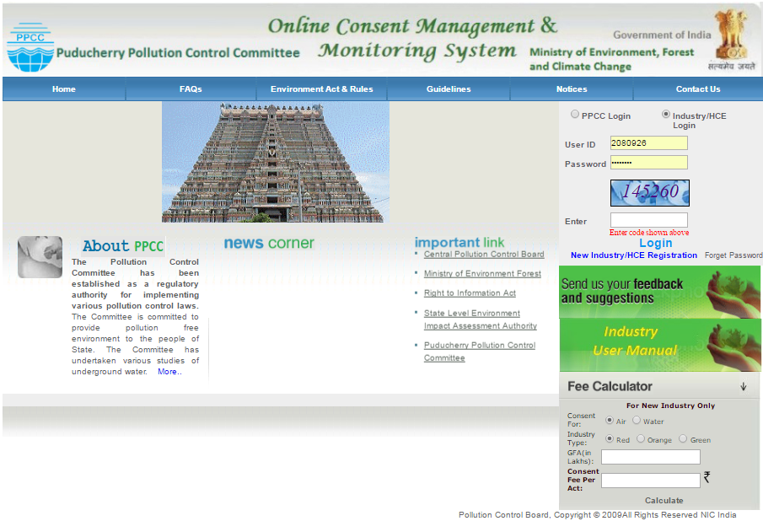

**Screen Shot: Home Page**

# Click “New Industry Registration”

* New Registration form will be displayed.
* Fill the required details in provided form and click “Submit”.
* Once submitted, System will validate the input data.
* If data is incorrect or mandatory filled not filled then system will prompt user to correct the information.
* If provided info of Industry user is correct then System will generate user name and Temporary password.
* After successful Registration, System will generate User name and temporary password, which will display on screen.
* Following are the screenshots of Industry Details and Occupier details.

Click on Occupier Details: For Occupier Details form

Click on Industry Details: For industry Details form

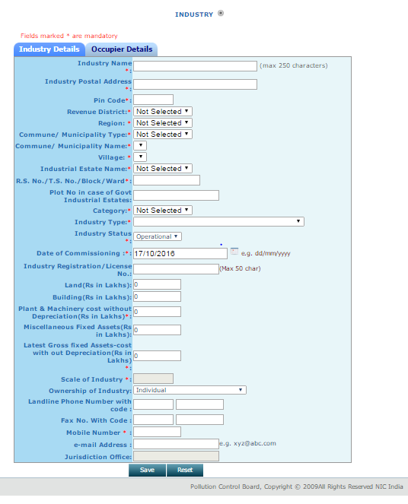

**Screenshot of Industry Details Form.**

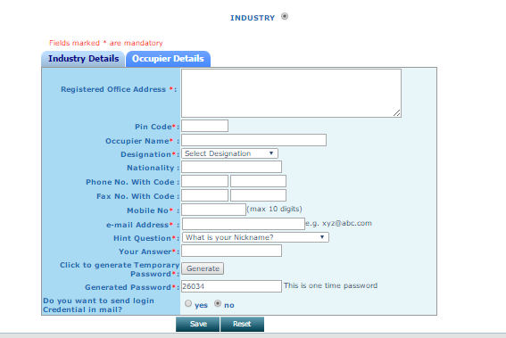

After filling both form completely. Click on Save Button.

**Screenshot of Occupier details form.**

* Fill all fields of the form correctly and Star marked fields are mandatory to fill, both in Industry Details and Occupier Details.
* After filling the mandatory Industry Details and Occupier Details, click on save button.

1. After successful Registration.

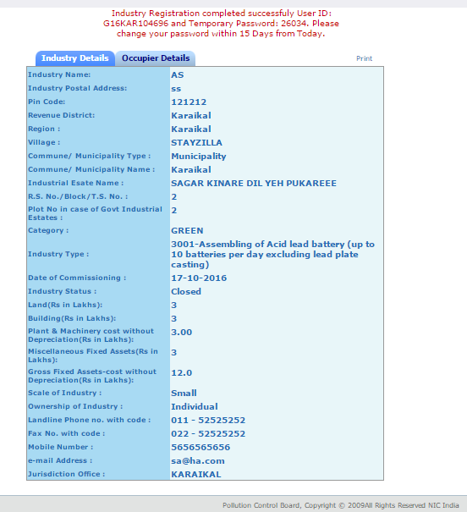

**Screenshot Successful registration**

* After successful Registration, System will generate User name and temporary password, which will display on screen.

1. Login.

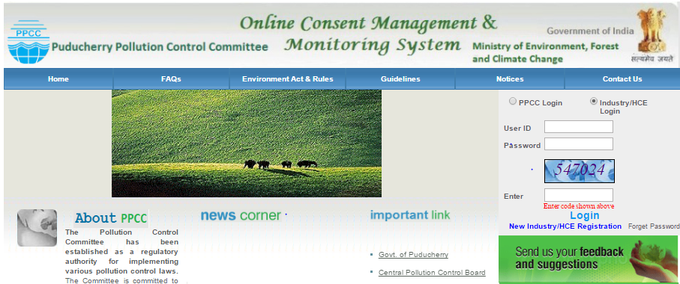

Log in as Industry.

**Screen Shot of login page**

* User need to login with the help of provided user id, Temporary password.
* Automatically change password screen will appear first on login.

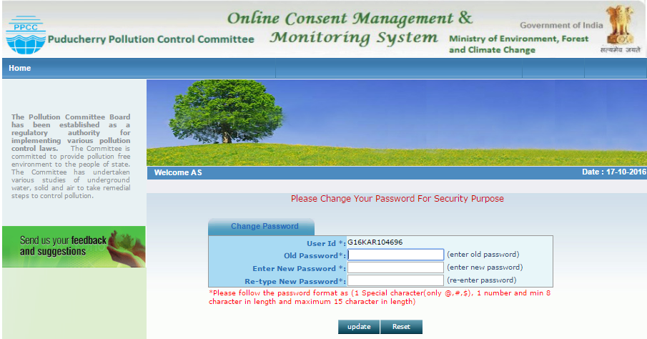

**Screenshot of Password change page**

* When user login as Industry User with provided User ID and Password, firstly it gives change password page as shown here.
* Change temporary password.
* Enter the old & new password.
* Enter the new password of minimum 8 characters size having at least 1 character, 1 digit and 1 special character (@, #, $ only).
* Click on update.
* After changing password successfully, you can login in to OCMMS by selecting radio button Industry and entering user id, password and Captcha code.
* Maximum 3 times you can enter wrong password, after that your account locks.
* Only way to unlock it is doing forget password.

1. Forget Password.

“Error Message” when user enter wrong user id or password.

Click on forget password, in case user forgot password or want to reset.

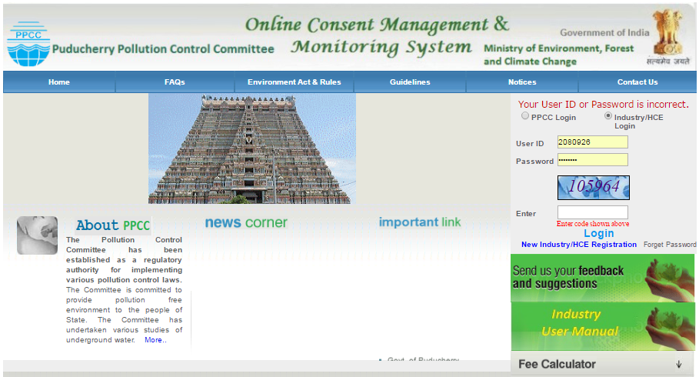

**Screen shot of Home Page**

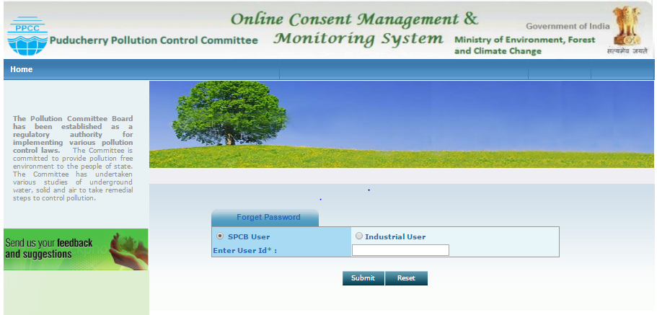

**Screenshot to Reset password.**

**Procedure for Forget Password**

* Click on industrial user Radio Button.
* Provide user name in the field.
* Click on submit button.
* New password will be generated and sent to the registered mobile number and e-Mail ID automatically.

Now, Login can be done using new password.

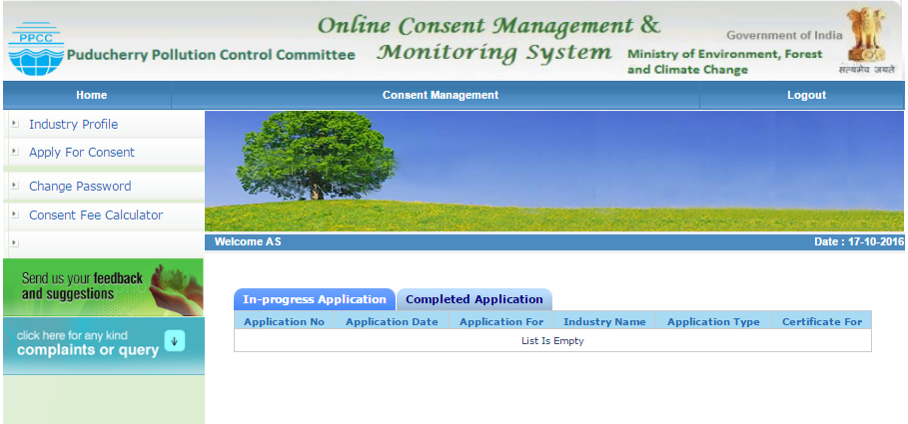

**Screenshot of Tabs- Inprogress and Completed application.**

* After logging in, the page appears as shown alongside.
* In progress application or completed application status can be viewed if already applied online.

1. Industry Profile:

With help of Industry profile user can check details provided by them during registration and can edit it.

Logout Button

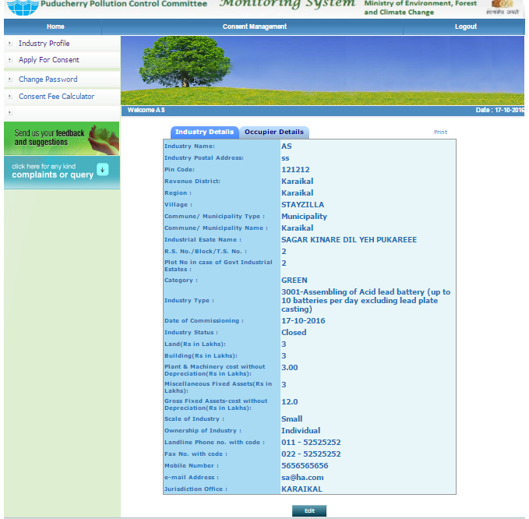

Industry and Occupier details.

User can also print Industry and Occupier details.

1. Apply for Consent.

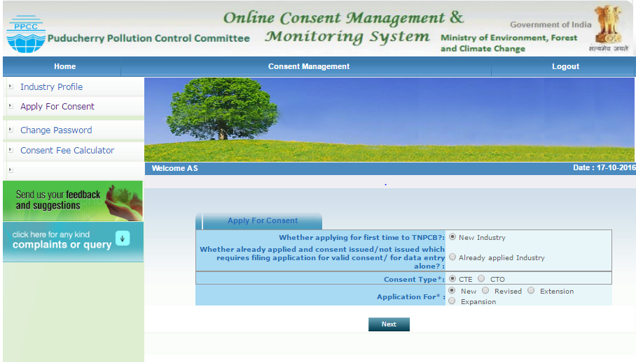

Screenshot of Apply for Consent

* Click on Apply for consent.
* Click on Consent Type as per requirement.

In case of CTE🡪New

🡪Revised

🡪Etension

🡪Expansion

In case of CTO🡪 Air🡪After CTE

🡪 Water🡪 After CTE

🡪 Both🡪 After CTE

🡪 Air🡪Renew

🡪 Water🡪 Renew

🡪 Both🡪 Renew

🡪 Air🡪Direct

🡪 Water🡪 Direct

🡪 Both🡪 Direct

* Click on consent for as per requirement.
* Click on Application for as per requirement.
* Click on Next.

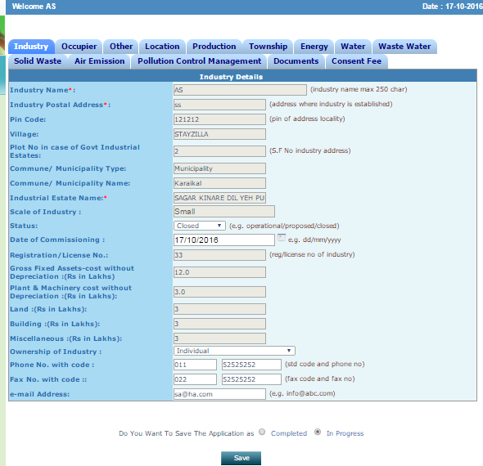

Click on industry or Occupier to view the industry Details.

**Screenshot of Industry Details.**

* Click in Industry details to view the Industry details.
* Click in Occupier details to view the Industry Occupier details.
* Click on Other tab to proceed for filling the application.

Fill in the required details; do not miss the fields that are marked mandatory

7.1 Other Tab.

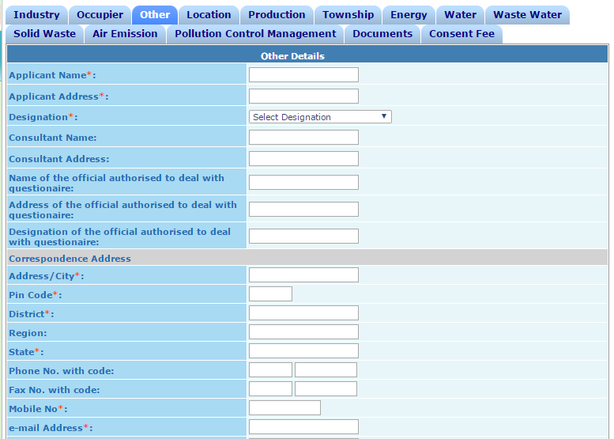

Click on Other tab to proceed for filling the application

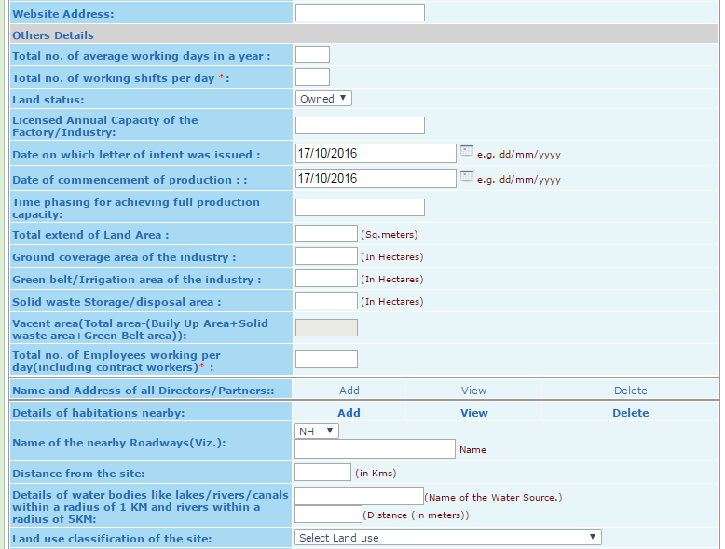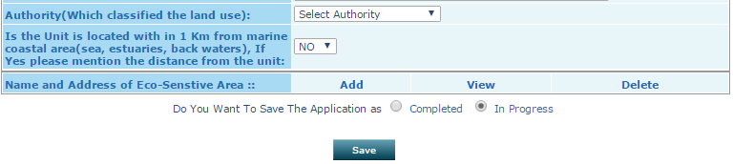

Here we can view the details added.

Click on Add button to fill details

Click on Delete to erase details added.

**Screenshot of Other Tab.**

Please do not click on completed until it is completed.

Click on in progress.

Click on Save button.

* Click **Save** in **“In Progress Mode”**
* Important: **Please do not click “Completed mode”** until application is fully completed.

# 7.2 Location Tab

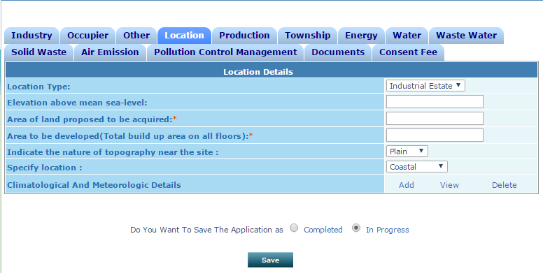

**Screenshot of Location Tab.**

* Click on Location tab.
* Clicks add to Climatological and Meteorologic Details.

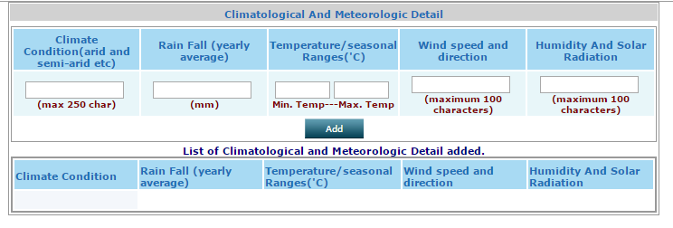

* Fill form accordingly..
* Click on add button to enter multiple details.
  1. Production Tab:
* Click on Production tab.
* Clicks add to enter production details.
* Fill form accordingly..

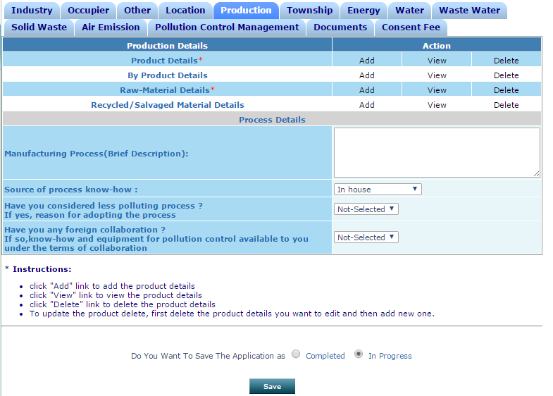

* 1. Town Ship:
* Click on Township tab.
* Fill form accordingly.

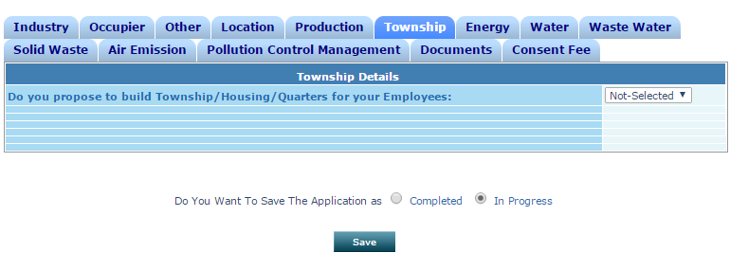

* 1. Energy:
* Click on Energy tab.
* Provide Energy details
* Fill form accordingly..

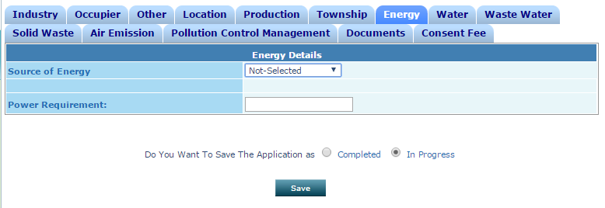

* 1. Water:
* Click on Water tab.
* Provide water details
* Fill form accordingly.

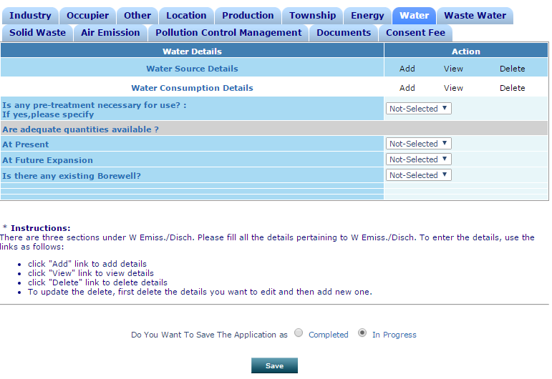

* 1. Waste Water:
* Click on Waste water tab.
* Provide Waste water details
* Fill form accordingly..

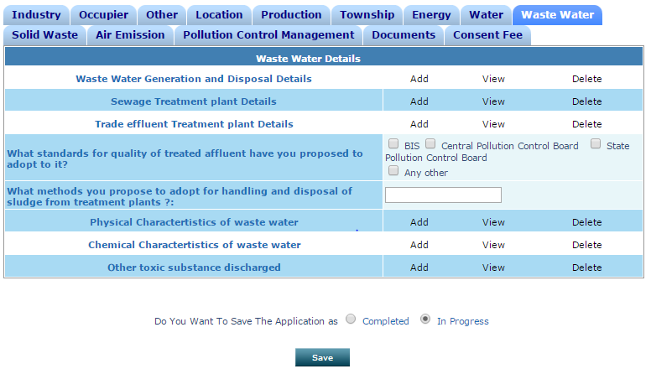

* 1. Solid Waste:
* Click on Solid waste tab.
* Provide Solid waste details
* Fill form accordingly..

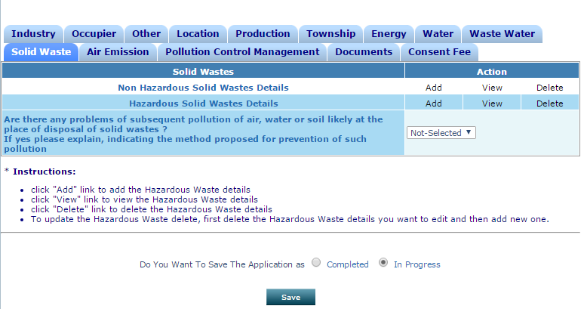

* 1. Air Emission:
* Click on Air Emission tab.
* Provide Air Emission details
* Fill form accordingly.

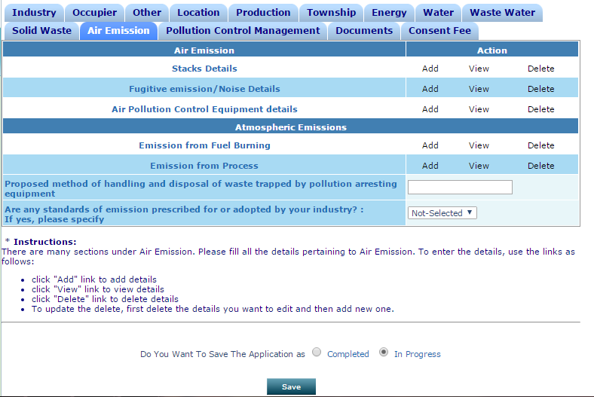

7.10Pollution Control Management:

* Click on Pollution Control Management tab.
* Provide Pollution Control Management details
* Fill form accordingly..

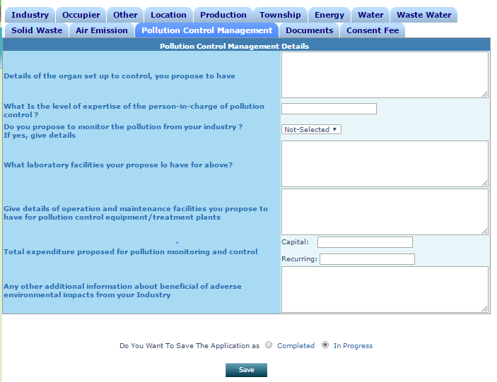

7.11Documents:

* Click on Document Tab.
* Provide Document details
* Fill form accordingly.

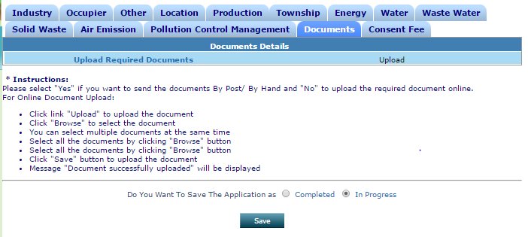

Screenshot of Documents Tab.

* Click on document tab, to upload required document.
* After clicking on upload button, following screen will appear.

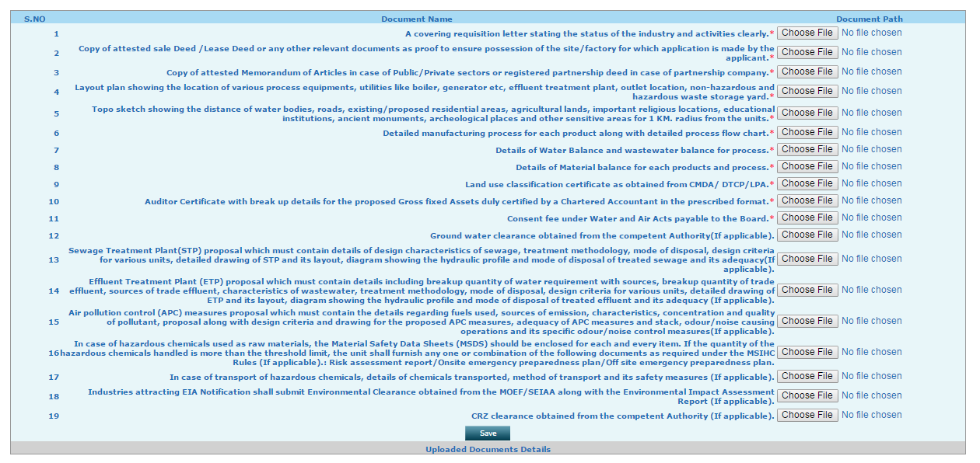

* Above is the list of documents required to upload for completion.
* All documents are mandatory to upload.
* After uploading all documents, click on save button.



* Message of successful uploading of document will appear on the screen.

# 7.3 Consent Fee Tab.

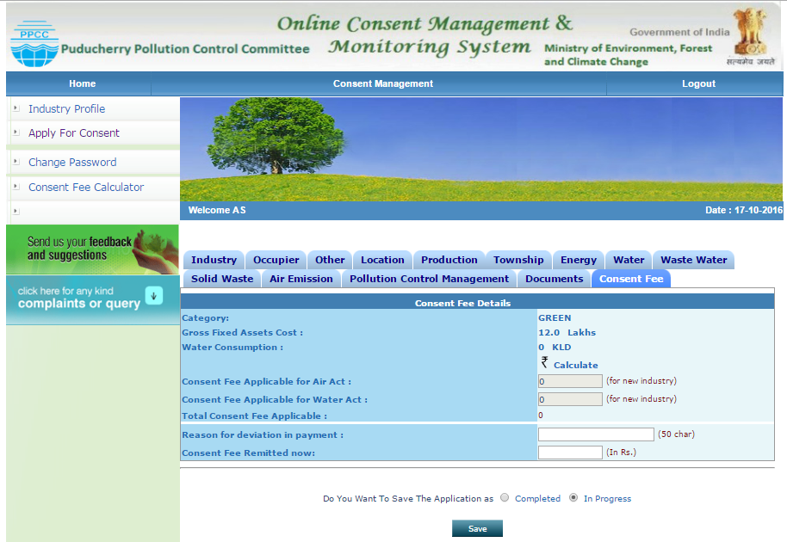

Auto calculated on basis of Provided info.

Click to know the Fees to be remitted.

**Screenshot of Fee Tab**

* After clicking on fee tab above screen will appear.
* Category will come automatically on basis of inputs provided.
* Gross fixed assets cost will come automatically on basis of Provided inputs.
* Water consumption will auto fetch on basis of provided inputs.
* Consent fee applicable for air and water act will auto fetch on pressing calculate button, on basis of provided inputs.
* Total consent fee will auto calculate as per PPCC rule.
* Capital investment will automatically fetch.
* Fee applicable will automatically update by clicking on Calculate button.
* Enter the reason for deviation in payment.
* Enter the consent fee remitted.
* Click on completed save button.
* Following screen will appear.

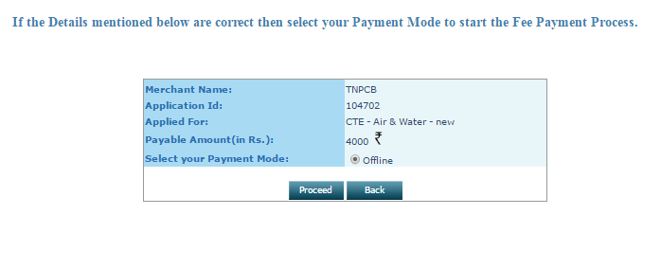

* Click on Proceed button, if you don’t want to make any change else click on back.
* Following screen will appear.

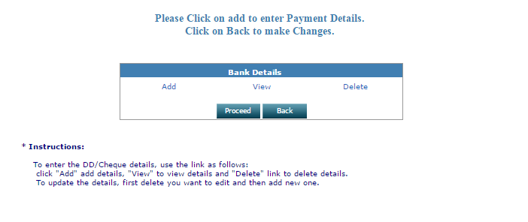

* Click on Add button, if you don’t want to make any change else click on back.
* Following screen will appear.

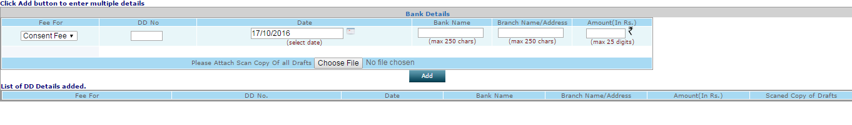

* Fill the above screen.
* Provide all required details.
* Following screen will appear on clicking add button.

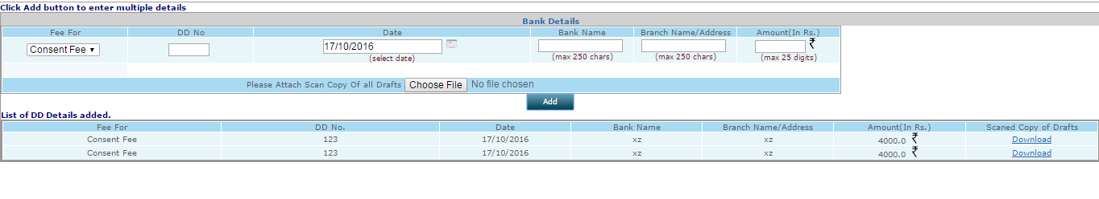

* Following screen will appear on successful completion of application.

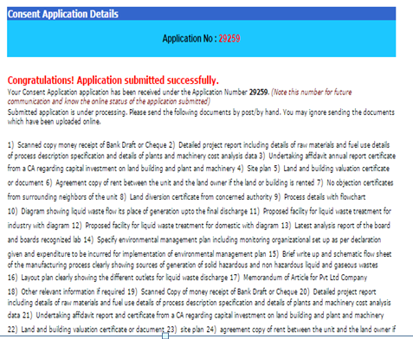

* Go to Home page.
* Click on completed application and click on application number link.

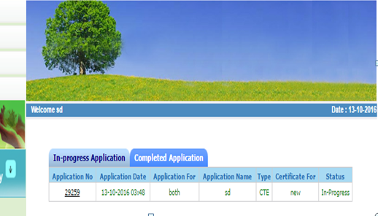

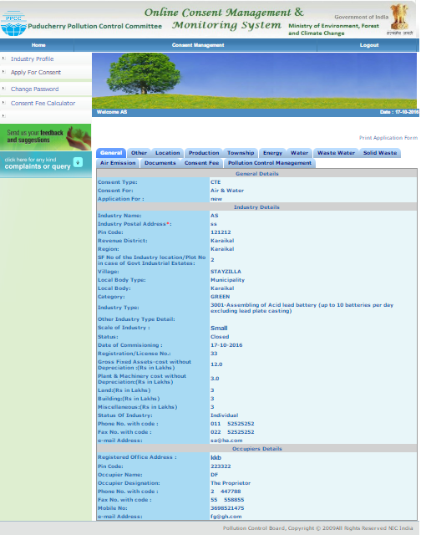

Click for printing to check submitted form.

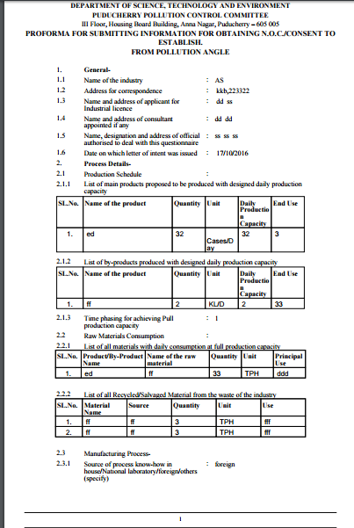

Application view like this, after Print.

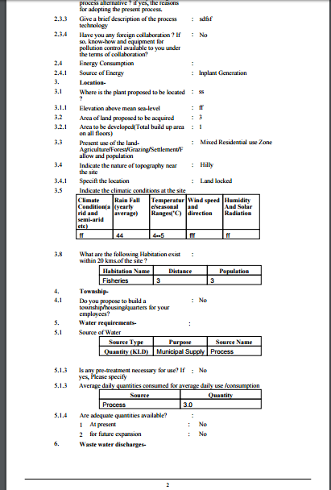

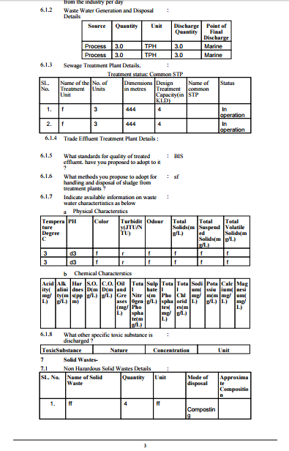

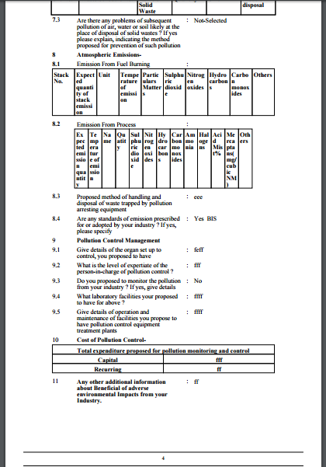



* Finally application is forwarded to SPCB end,

Thank You.